What is Azure Active directory?
Azure Active Directory is Microsoft’s multi-tenant, cloud-based directory and identity management service. For an organization, Azure AD helps employees sign up to multiple services and access them anywhere over the cloud with a single set of login credentials.

Multi Factor Authentication:

Multi-factor authentication is a process in which users are prompted during the sign-in process for an additional form of identification, such as a code on their cellphone or a fingerprint scan.
If you only use a password to authenticate a user, it leaves an insecure vector for attack. If the password is weak or has been exposed elsewhere, an attacker could be using it to gain access. When you require a second form of authentication, security is increased because this additional factor isn't something that's easy for an attacker to obtain or duplicate.
Azure AD Multi-Factor Authentication works by requiring two or more of the following authentication methods:
- Something you know, typically a password.
- Something you have, such as a trusted device that's not easily duplicated, like a phone or hardware key.
- Something you are - biometrics like a fingerprint or face scan.
Azure AD Multi-Factor Authentication can also further secure password reset. When users register themselves for Azure AD Multi-Factor Authentication, they can also register for self-service password reset in one step. Administrators can choose forms of secondary authentication and configure challenges for MFA based on configuration decisions.
You don't need to change apps and services to use Azure AD Multi-Factor Authentication. The verification prompts are part of the Azure AD sign-in, which automatically requests and processes the MFA challenge when needed.

Tenant:

When you sign up for a paid or trial subscription of Microsoft 365 Education, an Azure Active Directory (Azure AD) tenant is created as part of the underlying Office 365 services. Likewise, an Azure AD tenant is created when you sign up for Azure. You can also manually create an Azure AD tenant through the Azure portal and add Office 365 services at a later time.

What is an Azure AD tenant?
An Azure AD tenant provides identity and access management (IAM) capabilities to applications and resources used by your organization. An identity is a directory object that can be authenticated and authorized for access to a resource. Identity objects exist for human identities such as students and teachers, and non-human identities like classroom and student devices, applications, and service principles.
The Azure AD tenant is an identity security boundary that is under the control of your organization’s IT department. Within this security boundary, administration of objects (such as user objects) and configuration of tenant-wide settings are controlled by your IT administrators.

License types in AAD:

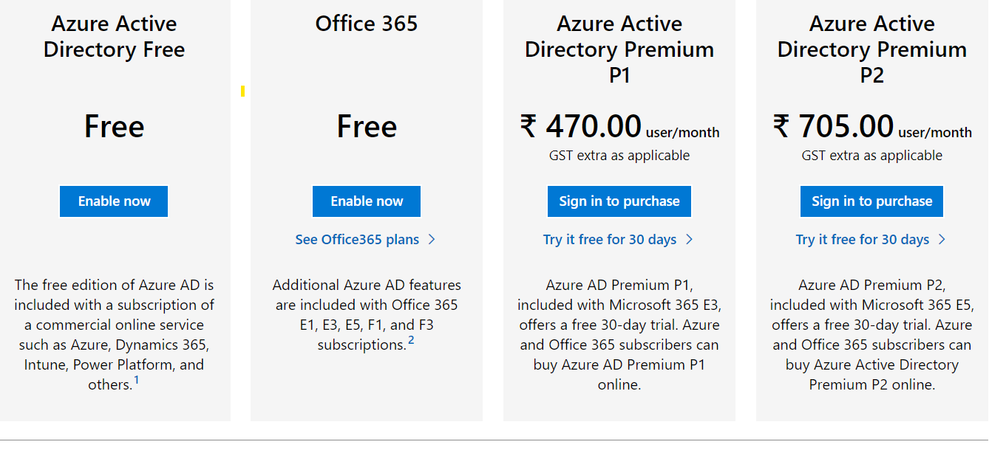

https://www.microsoft.com/en-in/security/business/identity-access/azure-active-directory-pricing

